Unit 3&4 Chemistry 2019 Trial Exam Solutions
Section A
1. D. The only non fossil fuel on the list is renewables at 2.1%. Therefore the % fossil fuel is
100 – 2.1 = 97.9%
2. B. Energy from natural gas is 3396.6 ×10¹⁵ J = 3.40 ×10¹⁸ J
From Data book, energy per gram of methane is 55600 J

mass methane = $\frac{total energy}{energy per gram}$= $\frac{3.40 ×{10}^{18} }{55600}$ = 6.12 × 10¹³ g = 6.12 × 10¹⁰ kg
3. B. n(CO₂) = = 6 mol ratio fuel: CO₂ is 3:6 or 1:2: this would match ethane.
4. D. The question asks for the bonding within the molecule, not between molecules, making
covalent the answer.
5. C. The most likely product to form from sugars is ethanol using fermentation. This process
would provide a better yield than biogas.
6. A. The zinc is being oxidized to Zn²⁺ ions, so the reaction will involve a loss of 2 electrons. The
hydroxide ions are included as the product is a solid. Zn(s) + 2OH⁻(aq) Zn(OH)₂(s) + 2e
7. D. The pH and the mass will remain constant. The pH is constant as one reaction produces OH⁻
ions while the other uses them.
8. A. Mercury is considered a dangerous heavy metal. It has been phased out of many common uses.
9. A. The half-equation balances easily without the need for acid conditions.
10. C. The question asks for the reverse reaction. The activation energy is always positive and the
enthalpy change for the reverse reaction is a positive one.
11. A. 2HI ⇌ H₂ + I₂
start 3 0 0
equilibrium 2.6 0.2 0.2
K = $\frac{0.1×0.1}{{1.3}^{2}}$ = 0.0059
12. D. Dilution will lower the red intensity. The reaction will move in the reverse direction as well,
also reducing the red intensity.
13. B. The addition of AgNO₃ lowers the concentration of SCN⁻. The reverse reaction is favoured
but it only partially replaces the SCN⁻ ions lost in the precipitate.
14. C. The NaCl must be fairly concentrated for chlorine to form at the anode instead of the
expected oxygen gas.
15. B. Q = It = 2.8 × 5 × 60 = 840 C
n(e) =$\frac{840}{96500}$ = 0.00870 mol n(H₂) = 0.00435 mol
V = n × 24.8 = 0.00435 × 24.8 = 0.108 L
16. A. The 2 bromine atoms are on carbons 3 and 4. They are named first as bromo is alphabetically
before methyl (the prefix di- is not counted).
17. B. Amines can be formed from the reaction between chloroalkanes and ammonia.
18. D. Isomers of all types can be formed from this molecular formula.

Structural geometric

Could have optical isomer
19. C. There are several significant peaks with low retention times. This would suggest they are
non-polar molecules that are not absorbed much on the stationary phase.
20. D. Butan-2-ol is drawn below. It has 5 hydrogen environments and 4 carbon environments.

21. D. Butanone will be the only alternative with 4 carbon environments and the large shift value on the left.

22. B. n(NaOH) = 0.0294 × 0.25 = 0.00735 mol
n(oxalic acid) = ½ n(NaOH) = 0.00368 mol
mass = 0.00368 × 90 = 0.331 g %(m/m) = 0.331×100/3 = 11.03 %
23. A. The molecule will be 2-chloropropane. The two parent molecular ion peaks suggest the
presence of chlorine and the relative molecular mass of 78.5 matches.
24. C. Half-equations are C₂H₆O(aq) + H₂O(l) C₂H₄O₂(aq) + 4H⁺(aq) + 4e⁻
Cr₂O₇²⁻(aq) + 14H⁺(aq) + 6e⁻ 2Cr³⁺(aq) + 7H₂O(l)
25. D. Glycogen is a polysaccharide and will have far more hydroxyl groups than the other
smaller molecules.
26. D. The general formula for a saturated fatty acid is C_{n}H_{2n}O₂. This would require 40 H atoms for
20 C atoms. As there are only 32 C atoms, there must be 4 double bonds.
27. A. The pH of saliva is relatively neutral. Saliva contains amylase. The pH of the stomach is
very low – pepsin works in this environment and the pH of the small intestine is alkaline to assit
the breakdown of triglycerides.
28. B. The structure of an amine and alcohol functional group
can be seen when examining the molecule.
29. C. The carbohydrate heats the water by 8⁰C. The fat heats the water by 8 × 37/16 = 18.5⁰C.
30. A. The acid is diluted in the dirty burette so the titre will be high. This will make the base appear to be more
concentrated than it really is.
Section B Short answer
Question 1 (9 marks)
a. i. 2 marks

ii. C₂₀H₃₈O₂(l) + 28.5O₂(g) 20CO₂(g) + 19H₂O(l)
2 marks

b. i. monounsaturated 1 mark

ii. Stearic acid will have the higher melting point. It is a longer molecule, so will have
more dispersion forces. Oleic acid also has a carbon-to-carbon double bond so the bends
in its molecules will lower its melting point. 2 marks

c. Canola is also a food item so competing demand for its use.
Growing crops requires resources and arable land – limits to this. 2 marks

Question 2 (10 marks)
a. anode: Zn(s) + 2OH⁻(aq) Zn(OH)₂(s) + 2e⁻ 2 marks
cathode: 2MnO₂(s) + H₂O(l) + 2e⁻ Mn₂O₃(s) + 2OH⁻(aq)

b. x - (-1.28) = 1.43 => voltage = 0.15 V 1 mark

c. In dry cells, the zinc is often the outer casing so the reaction of Zn(s) to Zn²⁺ ions means
the zinc metal casing is oxidising. In this cell, the zinc is not the outer casing so this is
not a problem. 2 marks

d. anode: O₂(g) + 2H₂O(l) + 4e 4OH⁻(aq) 3 marks
cathode: CH₄(g) + 8OH⁻(aq) CO₂(g) + 6H₂O(l) + 8e

overall: CH₄(g) + 2O₂(g) CO₂(g) + 2H₂O(l)

Question 3 (8 marks)
a. 4 marks
A: chloroethane

B: ethanol

C: ethanamine

D: ethanoic acid

b. i. C₂H₄(g) + HCl(g) CH₃CH₂Cl(g) 1 mark
ii. CH₃CH₂Cl(g) + NH₃(g) CH₃CH₂NH₂(g) + HCl(g) 1 mark

c. CH₃CH₂OH(l) + H₂O(l) CH₃COOH(l) + 4H⁺(aq) + 4e⁻ 1 mark

d. The addition reactions of ethene to chloroethane or to ethanol are 100% atom efficient as
there is only one product. 1 mark

Question 4 (11 marks)
a. i. The value of the equilibrium constant will not change as the temperature has not
been changed. 1 mark

ii. the decrease in volume will favour the back reaction to convert 3 particles to 2. The
net change in the concentration of SO₂ gas, however, will be an increase. The initial
volume drop increased the concentration more than the subsequent reverse reaction lowers
it. 2 marks

iii. the amount of SO₂ gas drops as the reverse reaction was favoured. 1 mark

b. i. 2 marks
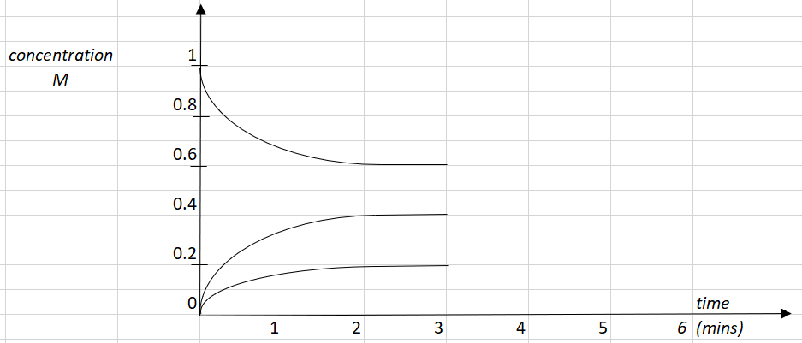

ii. K = = = 0.088 M 2 marks

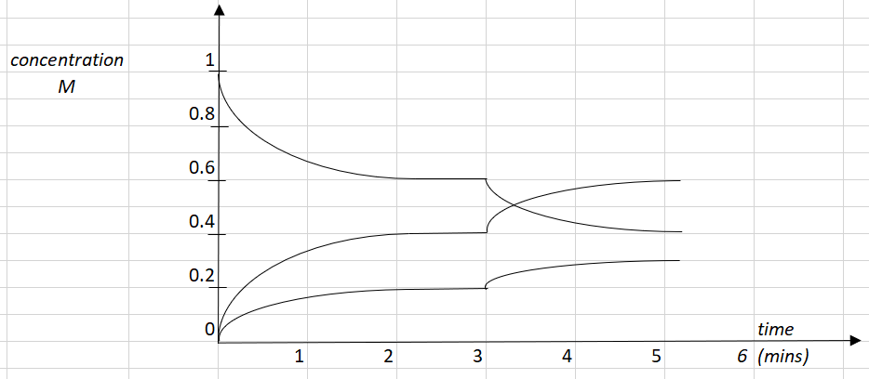
iii. 3 marks

Question 5 (9 marks)
a. i. C₃H₆O: propanal is consistent with being an aldehyde and having a molecular mass
of 58 as shown on the mass spectrum. 1 mark

ii. propanal 1 mark
b. propanoic acid 2 marks

c. 1 mark
Wave number (cm⁻¹) | Bond
3000 | C - H
1750 | C=O

d. 3 marks

Shift | Likely structure | Splitting pattern
1.1 | 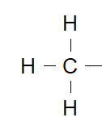 | Triplet as 2 neighbouring H atoms
2.4 | 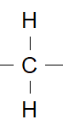 | Quartet as 3 neighbouring H atoms
9.8 | 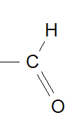 | Triplet as 2 neighbouring H atoms

e. Aldehydes can be formed when fats go rancid, so perhaps this molecule could be formed from the reaction of oxygen and unsaturated fat. 1 mark

Question 6 (8 marks)
a. i. Aqueous CuSO₄ or CuCl₂ would work. CuBr₂ would not work. 1 mark

ii. anode: 2H₂O(l) O₂(g) + 4H⁺(aq) + 4e 3 marks
cathode: Cu²⁺(aq) + 2e Cu(s)

overall equation: 2Cu²⁺(aq) + 2H₂O(l) 2Cu(s) + O₂(g) + 4H⁺(aq)

b. Q= It = 6.6 × 140 = 924 C
n_{e} = = 9.58 ×10⁻³ mol nO₂ = ¼ × n_{e} = 2.39 ×10⁻³ mol
V = = = 0.061 L 4 marks

Question 7 (10 marks)
a. i. Thermal energy can easily pass around the calorimeter if a biscuit is burnt under a
beaker of water. Combustion might be more complete in a bomb calorimeter and the
initial heat is not lost as you light the biscuit. 2 marks

ii. To ensure there is sufficient oxygen for complete combustion to occur. 1 mark

iii. To pass an electric current through the food to get it burning. 1 mark

b. 3 marks
CF = = 547 J⁰C⁻¹
Energy = CF × ΔT = 547 × 4.5 = 2460 J

Heat of combustion = 2460/0.962 = 2.58 kJ g⁻¹

c. i. The heat of combustion will drop as the energy per gram of carbohydrate is less than
that of fat. 1 mark

ii. - energy content: little change as energy of aspartame and sugar are similar
- taste: biscuit will taste horrible as this is a massive dose of aspartame 2 marks

Question 8 (7 marks)
a. i. Amylase enzyme is causing the hydrolysis of starch polysaccharide molecules to
smaller, sweeter saccharides. 1 mark

ii. Chewing your food is serving to break the food into smaller particles, increasing the
surface area and enabling the reaction to proceed at a faster rate. 1 mark

b. People who are lactose intolerant often do not naturally produce lactase. They might take
tablets so their body has the lactase required to break lactose into glucose and
galactose. 1 mark

c. i. Liver contains an enzyme that can serve as a catalyst for the decomposition of H₂O₂.
The shape of the enzyme complements the H₂O₂, providing an alternative reaction
pathway. 2 marks

ii. Potassium iodide is also a catalyst that provides an alternative reaction pathway. It is
however, not an enzyme, it is an inorganic catalyst. 2 marks

Question 9 (10 marks)
a. i. independent variable: the half-cell combination 1 mark
ii. dependent variable: the voltage produced 1 mark

b. 3 marks
Cu²⁺(aq) + 2e ⇌ Cu(s) 0.82 V
Pb²⁺(aq) + 2e ⇌ Pb(s) 0.54 V
Fe²⁺(aq) + 2e ⇌ Fe(s) 0.29 V
Zn²⁺(aq) + 2e ⇌ Zn(s) 0.00 V
Mg²⁺(aq) + 2e ⇌ Mg(s) - 1.10 V

c. The student’s conclusion is harsh. Her experiments do show the same order of reactivity of metals as the electrochemical series does. Her voltages are lower than those of the table but are still fairly proportional to the accepted values. 2 marks

d. The student should have used 1.0 M concentrations and 25 ⁰C to match standard conditions. The choice of sodium sulfate for a salt bridge is a poor one as it will form precipitates with solutions such as lead. 3 marks

Question 10 (8 marks)
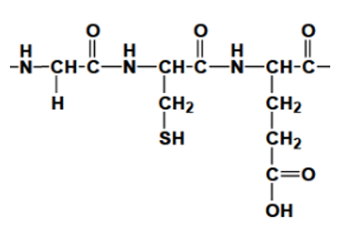
a. 5 marks

Primary structure: covalent N – C peptide links between neighbouring amino acids, formed by condensation polymerisation reactions between amino acids. Strong bonds.
Secondary structure: Hydrogen bonding between different parts of the protein chain formed as a result of the dipoles on the nitrogen, hydrogen and oxygen atoms of the peptide link. Causes coils and pleats.
Tertiary structure: bonding between – R groups that gives proteins their unique shape. May be dispersion forces, covalent bonds, dipole bonds or hydrogen bonds

b. Digestion of proteins starts mainly in the stomach where enzymes such as pepsin break the protein to smaller peptides. Digestion continues in the small intestine where other enzymes such as trypsin complete hydrolysis to amino acids. Amino acids dissolve in the blood and are transported to other parts of the body to be reassembled as new proteins or converted to energy. 3 marks

